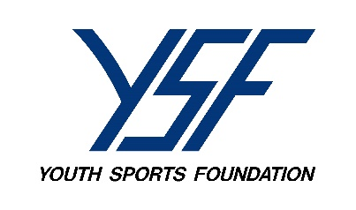
PLAYBOOK
January 2023

HAPPY NEW YEAR!
Welcome 2023! The YSF team is looking forward to a great YSF sports year. Honestly, 2022 was one of the BEST years in YSF sports I can remember! Hats off to our coaches, coordinators, players and parents. I anticipate the same in 2023. I hope you all had a wonderful Christmas season and are enjoying any winter activities you or your family may be involved in.
WELCOME/THANK YOU:
I just want to say thank you to all the outgoing coordinators and welcome in all you NEW coordinators. Please know we are here to help you every step of the way and looking forward to working with you!
WELCOME:
I would like to introduce Nick Swanson. Nick started at YSF as a southern Regional Director on January 2nd. Nick come to us from the Muscatine Schools where he was resource officer. Nick played both high school football and baseball in the Chicago area and played both sports in college at Iowa Wesleyan and Wisconsin Platteville. Nick is also the varsity head baseball coach in Winfield-Mount Union. Nick will be the Regional Director for the Greater Quad City conference and the Mississippi Valley conference. He will also oversee the main warehouse here in Muscatine. Please welcome Nick to our YSF team!
INVENTORIES:
A lot our town coordinators still need to turn in their year end 2022 inventory! Why does this matter? Because I had to order my equipment for the 2023 season in December. I am hoping for the ones who did do an inventory or communicated with their Regional Director in November will have what they need by June. We require a year end inventory from our YSF coordinators not only for insurance purposes, but also so we are aware of what may need replaced for our towns! So please if you have not turned one in, we still need you to inventory what you have, even though equipment for the 2023 season has already been budgeted and orders placed.

OTHER YSF SPORTS:
The Youth Sports Foundation does offer other sports activities for youth! All you need to do is contact your Regional Director and ask about them. We offer Co-ed track and field, Cheerleading, volleyball and hoping to get a summer lacrosse league going. If you are interested in any or all of these for your community, please reach out to us!
7 ON 7 (Spring) football:
We have tried doing 7 on 7 before and have had few towns interested. We would really like to start a Spring League. Please let us know if you are interested. This would be a 5th & 6th grade and 7th & 8th grade league. We need to start planning so the sooner we hear from towns the better.
Price increase:
The YSF board in December voted to increase our football program fees by $10 in 2023. We’ve not had an increase since 2019. This comes after all equipment, insurance and certification cost are going up in 2023. We are not increasing fees in track, cheerleading or volleyball.

2023 Coordinator Packets will be mailed out to our YSF coordinators in February. If you know you are stepping down as your town coordinator and have communicated with the YSF office of your replacement, the packet will mailed to your replacement. If you are stepping down, but have not found a replacement at this time, the packet will be mailed to you. Please hang onto it and pass it to the new coordinator. Thank you!

MAKE TODAY A GREAT DAY! LIFE IS TOO SHORT!

JIM

